A new book coming out soon!

‘This brave young officer’
by John Dewhurst
Author of ‘Thank God the East Surreys are there!’

The story of Lieutenant Francis Edward Blackwood, killed in action at Satiru near Sokoto in Northern Nigeria on 14th February 1906.
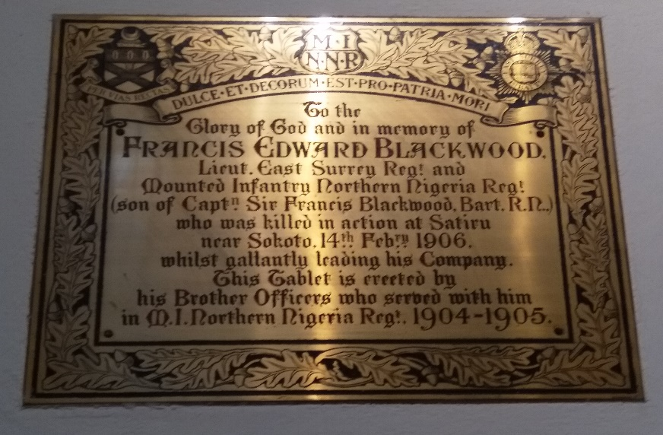

This book John Dewhurst writes) is an unlikely by-product of the 2020 Covid-19 lockdown. The months of unanticipated leisure, extending from late March until August, provided me with an extended opportunity (using the almost infinite resources of the internet, especially the websites of The National Archives, The British Newspaper Library, The Times Digital Archive, the JSTOR digital library of academic journals, and of course Wikipedia) to investigate the story behind the Blackwood Memorial in All Saints Church, Kingston-upon-Thames, which had long been a source of fascination for me. I’d often wondered, as I looked up at the handsome brass plaque, just how it was that a young officer of the East Surrey Regiment came to be commanding a company of Mounted Infantry with the Northern Nigeria Regiment in 1906.
The answers to this question and to several others, as they gradually emerged from my enquiries, told an uncannily familiar story. A young British infantry officer was killed in action far from his home during an Islamic-inspired insurgency. But this story was not set in late 20th - early 21st century Iraq or Afghanistan, where so many young lives have been lost. It was about an incident that took place in northern Nigeria in the first decade of the 20th century.
This book tells the story.
To order a limited edition copy please contact heritage@allsaintskingston.co.uk

