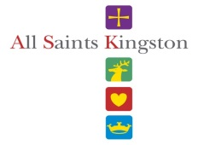

**Stained Glass Spotter Sheet**

Can you spot these characters in the stained glass windows?

What is this man holding?

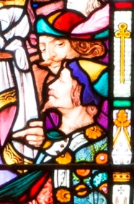

A wine glass

Window 19

Which college is this the shield for?

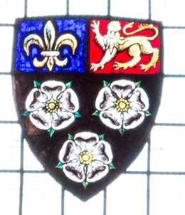

Kings College Cambridge

Window 14

What organisation does this badge represent?

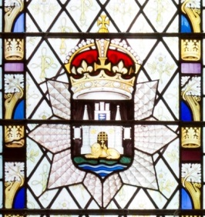

East Surrey Regiment

Window 17

What is pictured on this man’s sack?

A hand

Window 15

**ANSWER SHEET**

How many towers can you see?

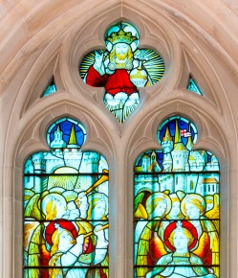

10

Window 10

What am I wearing around my waist?

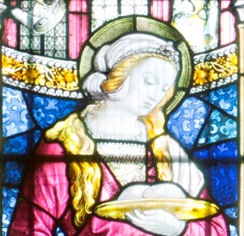

Keys

Window 8

What is my name?

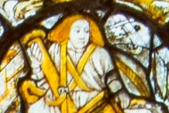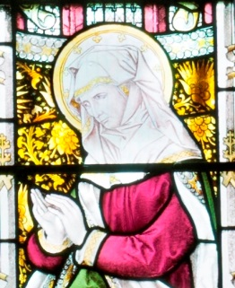

Anna, the Prophetess

Window 7

How many angels can you see in this window?

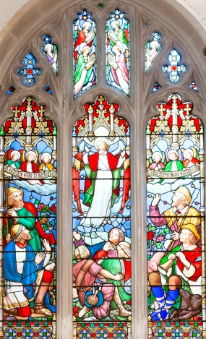

13

Window 3