The Parish Church of All Saints
6 August 2017 – The Transfiguration of Our Lord

You are very welcome to All Saints this morning for this Eucharist (Holy Communion). A special welcome to Charlotte Jessica Martin and Kellie Marie Denise McCord, who are being baptised today, their family and friends.
Children are very welcome here and, if they want to, they can take part in the children’s activities that happen at the east end of the church and in the small chapel nearby.
Children leave after the first hymn and return for the Communion.
Today we sing the mass setting, number 541 in the hymn book, starting at the Gloria.

The service starts on page 1 of the green booklet.

The opening hymn is 234 (second tune).

We sing the Gloria (the words are on page 17).

We say together the collect – the special prayer for this Sunday.

Father in heaven,
whose Son Jesus Christ was wonderfully transfigured
before chosen witnesses upon the holy mountain,
and spoke of the exodus he would accomplish
at Jerusalem:
give us strength so to hear his voice and
bear our cross
that in the world to come we may see him
as he is;
who is alive and reigns with you,
in the unity of the Holy Spirit,
one God, now and for ever.
Amen
The reading from the Old Testament today is Daniel 7:9-10, 13-14; which is then followed by the New Testament reading 2 Peter 1:16-19.

The Gradual Hymn is 389 after which we remain standing and turn to face the centre of the church from where the Gospel is read.

Today’s Gospel is Luke 9:28-36 – the text is on the back of this pew sheet.

The preacher today is the Rector, Jonathan Wilkes.

After the sermon we will process to the font singing hymn 387, for the baptism of Charlotte Jessica Martin and Kellie Marie Denise McCord. The words for the baptism start on page 14 of the green booklet.

After the Peace we sing the Offertory Hymn 401 during which a collection is taken for the work of the
church, and the bread and wine for the Eucharist are brought to the altar.

The service continues with the Preparation of the Table on page 7 of the green booklet.

This morning we will use Eucharistic Prayer A.

After Communion the Celebrant will say:
Holy God,
we see your glory in the face of Jesus Christ:
may we who are partakers at his table
reflect his life in word and deed,
that all the world may know
his power to change and save.
This we ask through Jesus Christ our Lord.
Amen

The Final Hymn is 494.

After the service, refreshments are served. Please feel very welcome to stay and enjoy, and if you have not been to the church before, please do introduce yourself to one of the clergy or churchwardens – we’d love to meet you.

This sheet is for you to take home.

Please keep your belongings with you at all times.

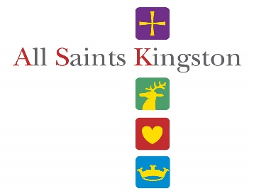
NOTICES AND NEWS

10 August 11am-2pm Thumbs UP It’s Thursday Activity Day – Nature Detectives
17 August 11am-2pm Thumbs UP It’s Thursday Activity Day – Building All Saints
28 August-10 September Artful Dodger Art Exhibition

An HLF application submitted
Just to let you know that we have submitted our HLF application for about £4.5 million for a new museum project in the Town, to include the use of a new building on our north lawn. The decision whether to fund us will be taken in late September.

Heritage Volunteers
We are in GREAT need of some help on Thursday the 10th, 17th and 24th August for our Thumbs up its Thursday heritage activities. Can you help? If so, please let Jonathan know or sign up on the sheet by the south door

The Union Street bollard
Has been changed and now is s slightly different system. The key is in the Vestry Office but if you think that you will need to use it please contact the office during office hours to have it explained.

Work to the Tower
Is finished. Welcome back the Bellringers!

Summer Stay & Play Activity Mornings
for under 5’s
Wednesdays 9th, 16th, 23rd & 30th August from 10am to 12noon in the church. All children aged under 5 years and their cares welcome. £3 per family. Come and join the in the fun; activities will include Arts, Crafts, Messy Play, Cooking, Sports and More. The last session will include Hawaiian themed beach party in the garden (weather permitting). For more information please contact Emma Lloyd-Williams. emmalloydwilliams@me.com or 07985521551.

Heritage Reminiscence at All Saints
All Saints is after your memories! As part of our heritage project, we are looking to collect people’s memories of All Saints over the years and create an archive and exhibition to be held in the church in 2018. What is your favourite memory of All Saints? Do you have any images of how the building used to look or events that were held here? We are looking to collect pictures, written memories, articles & clippings, recorded interviews and videos. If you would like to contribute anything, or you would like more information, please contact Kate Kern at heritage@allsaintskingston.co.uk or on 0208 541 5371.

Stewarding events
The church is used a lot by other groups for different events - it’s part of the ministry by which we serve the community. At each event we need a “steward” to be our representative. Stewards not only get access to the event itself but also a free pass to all events and concerts at All Saints by way of a thank you. we need a few more. Please speak to Jonathan of let the office know if you can help.

Christian Aid Week in Kingston. During May, churches around Kingston together collected over £10,750 (Gift Aid will add more) to support Christian Aid’s work to help people of all faiths, throughout the world, fight their way out of poverty. Of this total, All Saints were responsible for raising over £2,200. Thank you again to all those who helped.

Richmond Riverside Walk on Saturday 23 September. Speak to Keith Long or Ian Williamson if you'd like to join in on a 6.5 mile sponsored walk along the Thames from Richmond to Kew being organised by Christian Aid.

'Viewpoints'. Carol Mackay, Ian Williamson and the rest of the Artful Dodgers invite you to an Evening Opening of their new exhibition of paintings in the church on Wednesday, 30 August from 7pm. Refreshments will be available; donations to Christian Aid are invited. All are welcome.

Weekend Vergers
Can you spare an hour or two every now and then at the weekend to help be our welcoming presence in the church for visitors? Please let Rosemary Gout know if you can.

Readings for 13 August 2017

9.30am I Kings 19:9-18; Romans 10:5-15; Matthew 14:22-33

6pm I Kings 11:41-12:20; Acts 14:8-20

Church office: Tel 020 8546 5964 info@allsaintskingston.co.uk
www.allsaintskingston.co.uk
Development office: klong@WhereEnglandBegan.co.uk
Tel 07444 548 423
www.WhereEnglandBegan.co.uk
Rector: Rev Jonathan Wilkes Tel: 020 3132 8717
Email: jonathan@allsaintskingston.co.uk

St JOHN THE EVANGELIST NOTICES AND NEWS
www.stjohnskingston.co.uk

LITTLE GROOVERS will not be meeting during the summer school holidays. But please see the Stay and Play Activity mornings for the under fives. Little Groovers will be back again on Tuesday 5th September

KIDS CHURCH ACTIVITY DAYS IN THE SUMMER: Wed 2nd/Thurs 3rd/Fri 4th August.
We are running 3 activity days in the summer for children aged 5 to 11 exploring the Lord’s Prayer through crafts, drama, games and reflection time. The days will run from 10am until 3pm and there will be 20 spaces available. Registration forms are available from Vicky. This is for children without their parents and there will be a small charge. If you would like more information or would like to help please speak to Vicky.

SUMMER STAY & PLAY ACTIVITY MORNINGS
Wednesday 9th, 16th, 23rd & 30th of August
10am - 12pm
Children aged under 5 years. £3 per family.

Come and join in the fun. Activities will include Arts, Crafts, Messy Play, Cooking, Sports and more. The last session will include Hawaiian themed beach party in the garden. (Weather permitting)
Coffee & Cake available. For more information please contact Emma Lloyd-Williams. emmalloydwilliams@me.com or 07985521551

SERVICES AT ST JOHN’S
1st Sunday of the month: 10am Family Communion
2nd, 4th and 5th Sundays of the month: 10am Parish Communion with children’s church
3rd Sunday of the month: 9am Holy Communion
10am Sacred Space with children’s church
CONTACTS FOR ST JOHN'S
Vicar: Revd Vicky Maunder
vicar@stjohnskingston.co.uk or 020 8546 9882.
Vicky works part time and is available on Wednesdays
Thursdays, Fridays and Sunday mornings.
Administrator:Frances Hazelgrove Tel: 07952085661 admin@stjohnskingston.co.uk

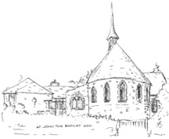
St. John the Baptist Church
Kingston & Putney Vale

Monday Afternoon Club 1.30 – 3.30 pm at St John the Baptist Church Hall
For more information contact Ruth Ruocco Brown
Mob: 07790 899987 Email: ruthderina@tiscali.co.uk
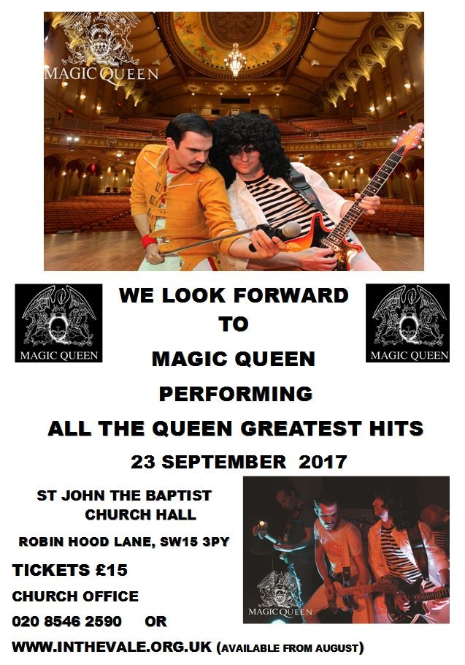

A Great Fun Holiday Club for age 5 to 11
Come along play games
make slime and many more fun things.

August 21st to 23rd
10 till 3pm
Cost £5 per day,
plus bring a packed lunch.

To book a place e-mail
stjohns@inthevale.org.uk
Or ring 02085464079

THE READINGS

Daniel 7:9-10, 13-14

As I watched, thrones were set in place, and an Ancient One took his throne; his clothing was white as snow, and the hair of his head like pure wool; his throne was fiery flames, and its wheels were burning fire. A stream of fire issued and flowed out from his presence. A thousand thousand served him, and ten thousand times ten thousand stood attending him. The court sat in judgement, and the books were opened.
As I watched in the night visions, I saw one like a human being coming with the clouds of heaven. And he came to the Ancient One and was presented before him. To him was given dominion and glory and kingship, that all peoples, nations, and languages should serve him. His dominion is an everlasting dominion that shall not pass away, and his kingship is one that shall never be destroyed.

2 Peter 1:16-19

We did not follow cleverly devised myths when we made known to you the power and coming of our Lord Jesus Christ, but we had been eyewitnesses of his majesty. For he received honour and glory from God the Father when that voice was conveyed to him by the Majestic Glory, saying, ‘This is my Son, my Beloved, with whom I am well pleased.’ We ourselves heard this voice come from heaven, while we were with him on the holy mountain.
So we have the prophetic message more fully confirmed. You will do well to be attentive to this as to a lamp shining in a dark place, until the day dawns and the morning star rises in your hearts.

Luke 9:28-36

Jesus took with him Peter and John and James, and went up on the mountain to pray. And while he was praying, the appearance of his face changed, and his clothes became dazzling white. Suddenly they saw two men, Moses and Elijah, talking to him. They appeared in glory and were speaking of his departure, which he was about to accomplish at Jerusalem. Now Peter and his companions were weighed down with sleep; but since they had stayed awake, they saw his glory and the two men who stood with him. Just as they were leaving him, Peter said to Jesus, ‘Master, it is good for us to be here; let us make three dwellings, one for you, one for Moses, and one for Elijah’—not knowing what he said. While he was saying this, a cloud came and overshadowed them; and they were terrified as they entered the cloud. Then from the cloud came a voice that said, ‘This is my Son, my Chosen; listen to him!’ When the voice had spoken, Jesus was found alone. And they kept silent and in those days told no one any of the things they had seen.

