The Parish Church of All Saints
20 August 2017 – 10th Sunday after Trinity

You are very welcome to All Saints this morning for this Eucharist (Holy Communion). A special welcome to Charles Henry Dutton, who is being baptised today, his family and friends.
Children are very welcome here and, if they want to, they can take part in the children’s activities that happen at the east end of the church and in the small chapel nearby.
Children leave after the first hymn and return for the Communion.
Today we sing the mass setting, number 541 in the hymn book, starting at the Gloria.

The service starts on page 1 of the green booklet.

The opening hymn is 406.

We sing the Gloria (the words are on page 17).

We say together the collect – the special prayer for this Sunday.

Let your merciful ears, O Lord,
be open to the prayers of your
humble servants;
and, that they may obtain their petitions,
make them to ask such things as shall
please you;
through Jesus Christ your Son our Lord,
who is alive and reigns with you,
in the unity of the Holy Spirit,
one God, now and for ever.
Amen
The reading from the Old Testament today is Isaiah 56:1, 6-8; which is then followed by the New Testament reading Romans 11:1-2a,
29-32.

The Gradual Hymn is 357 after which we remain standing and turn to face the centre of the church from where the Gospel is read.

Today’s Gospel is Matthew 15:21-28 – the text is on the back of this pew sheet.

The preacher today is the Rector, Jonathan Wilkes.

After the sermon we will process to the font singing hymn 387, for the baptism of Charles Henry Dutton. The words for the baptism start on page 14 of the green booklet.

After the Peace we sing the Offertory Hymn 427 during which a collection is taken for the work of the church, and the bread and wine for the Eucharist are brought to the altar.

The service continues with the Preparation of the Table on page 7 of the green booklet.

This morning we will use Eucharistic Prayer A.

After Communion the Celebrant will say:
God of our pilgrimage,
you have willed that the gate of mercy
should stand open for those who trust in you:
look upon us with your favour
that we who follow the path of your will
may never wander from the way of life;
through Jesus Christ our Lord.
Amen

The Final Hymn is 366.

After the service, refreshments are served. Please feel very welcome to stay and enjoy, and if you have not been to the church before, please do introduce yourself to one of the clergy or churchwardens – we’d love to meet you.

This sheet is for you to take home.

Please keep your belongings with you at all times.

NOTICES AND NEWS

24 August 11am-2pm Thumbs Up it’s Thursday Activity Day – Crafty Allsorts
28 August-10 September Artful Dodger Art Exhibition

An HLF application submitted
Just to let you know that we have submitted our HLF application for about £4.5 million for a new museum project in the Town, to include the use of a new building on our north lawn. The decision whether to fund us will be taken in late September.

Heritage Volunteers
We are in GREAT need of some help on Thursday the 24th August for our Thumbs up it’s Thursday heritage activities. Can you help? If so, please let Jonathan know or sign up on the sheet by the south door.

Organ Recital
There is an organ recital by Matthew, our organist, at St Stephen’s, Walbrook (London) on Friday 25th August from 12.30 to 13.30. All welcome. Admission free.

The Union Street bollard
Has been changed and now is a slightly different system. The key is in the Vestry Office but if you think that you will need to use it please contact the office during office hours to have it explained.

Work to the Tower
Is finished. Welcome back the Bellringers!

Summer Stay & Play Activity Mornings
for under 5’s
Wednesdays 23rd & 30th August from 10am to 12noon in the church. All children aged under 5 years and their cares welcome. £3 per family. Come and join the in the fun; activities will include Arts, Crafts, Messy Play, Cooking, Sports and More. The last session will include Hawaiian themed beach party in the garden (weather permitting). For more information please contact Emma Lloyd-Williams. emmalloydwilliams@me.com or 07985521551.

Heritage Reminiscence at All Saints
All Saints is after your memories! As part of our heritage project, we are looking to collect people’s memories of All Saints over the years and create an archive and exhibition to be held in the church in 2018. What is your favourite memory of All Saints? Do you have any images of how the building used to look or events that were held here? We are looking to collect pictures, written memories, articles & clippings, recorded interviews and videos. If you would like to contribute anything, or you would like more information, please contact Kate Kern at heritage@allsaintskingston.co.uk or on 020 8541 5371.

Stewarding events
The church is used a lot by other groups for different events – it’s part of the ministry by which we serve the community. At each event we need a “steward” to be our representative. Stewards not only get access to the event itself but also a free pass to all events and concerts at All Saints by way of a thank you. We need a few more. Please speak to Jonathan or let the office know if you can help.

Help to support Kingston Street Pastors. Waitrose in Kingston has chosen Street Pastors as one of its nominated charities this month. You can help by voting for them using the green counter system in the store when shopping. Find out more about Street Pastors at www.kingston.streetpastors.org.uk

Richmond Riverside Walk on Saturday 23 September. Speak to Keith Long or Ian Williamson if you'd like to join an All Saints group taking part in a 6.5 mile sponsored walk along the Thames from Richmond to Kew, organised by Christian Aid.

'Viewpoints'. Carol Mackay, Ian Williamson and the rest of the Artful Dodgers invite you to an Evening Opening of their new exhibition of paintings in the church on Wednesday, 30 August from 7pm. Refreshments will be available; donations to Christian Aid are invited. All are welcome.

Weekend Vergers
Can you spare an hour or two every now and then at the weekend to help be our welcoming presence in the church for visitors? Please let Rosemary Gout know if you can.

Readings for 27 August 2017

9.30am Isaiah 51:1-6; Romans 12:1-8; Matthew 16:13-20
6pm 2 Kings 6:8-23; Acts 17:15-end

Church office: Tel 020 8546 5964 info@allsaintskingston.co.uk
www.allsaintskingston.co.uk
Development office: klong@WhereEnglandBegan.co.uk
Tel 07444 548 423
www.WhereEnglandBegan.co.uk
Rector: Rev Jonathan Wilkes Tel: 020 3132 8717
Email: jonathan@allsaintskingston.co.uk

St JOHN THE EVANGELIST NOTICES AND NEWS
www.stjohnskingston.co.uk

LITTLE GROOVERS will not be meeting during the summer school holidays. But please see the Stay and Play Activity mornings for the under fives. Little Groovers will be back again on Tuesday 5th September

SUMMER STAY & PLAY ACTIVITY MORNINGS
Wednesday, 23rd & 30th of August
10am - 12pm
Children aged under 5 years. £3 per family.

Come and join in the fun. Activities will include Arts, Crafts, Messy Play, Cooking, Sports and more. The last session will include Hawaiian themed beach party in the garden. (Weather permitting)
Coffee & Cake available. For more information please contact Emma Lloyd-Williams. emmalloydwilliams@me.com or 07985521551

SERVICES AT ST JOHN’S
1st Sunday of the month: 10am Family Communion
2nd, 4th and 5th Sundays of the month: 10am Parish Communion with children’s church
3rd Sunday of the month: 9am Holy Communion
10am Sacred Space with children’s church

CONTACTS FOR ST JOHN'S
Vicar: Revd Vicky Maunder
vicar@stjohnskingston.co.uk or 020 8546 9882.
Vicky works part time and is available on Wednesdays
Thursdays, Fridays and Sunday mornings.
Administrator:Frances Hazelgrove Tel: 07952085661 admin@stjohnskingston.co.uk

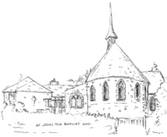
St. John the Baptist Church
Kingston & Putney Vale

Monday Afternoon Club 1.30 – 3.30 pm at St John the Baptist Church Hall
For more information contact Ruth Ruocco Brown
Mob: 07790 899987 Email: ruthderina@tiscali.co.uk
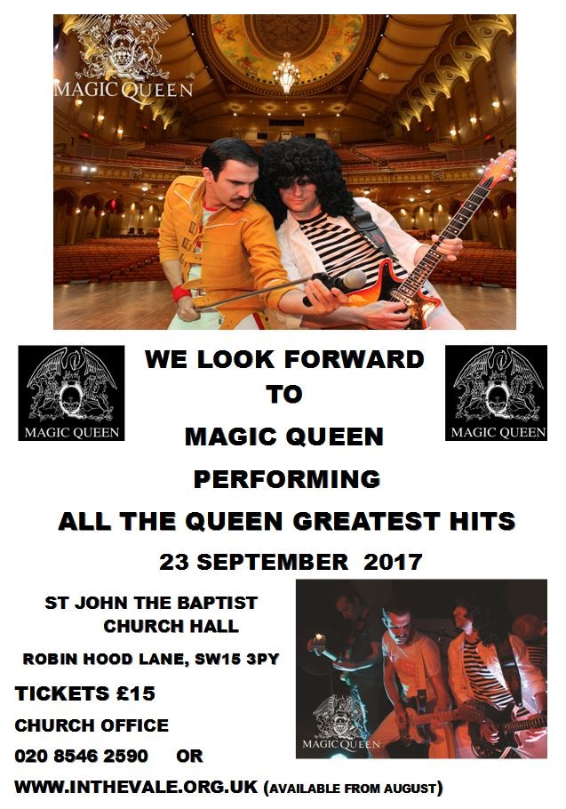

A Great Fun Holiday Club for age 5 to 11
Come along play games
make slime and many more fun things.

August 21st to 23rd
10 till 3pm
Cost £5 per day,
plus bring a packed lunch.

To book a place e-mail
stjohns@inthevale.org.uk
Or ring 02085464079

THE READINGS

Isaiah: 56:1, 6-8

Thus says the Lord: Maintain justice, and do what is right, for soon my salvation will come, and my deliverance be revealed.
And the foreigners who join themselves to the Lord, to minister to him, to love the name of the Lord, and to be his servants, all who keep the sabbath, and do not profane it, and hold fast my covenant – these I will bring to my holy mountain, and make them joyful in my house of prayer; their burnt-offerings and their sacrifices will be accepted on my altar; for my house shall be called a house of prayer for all peoples.
Thus says the Lord God, who gathers the outcasts of Israel, I will gather others to them besides those already gathered.

Romans 11:1-2a, 29-32

I ask, then, has God rejected his people? By no means! I myself am an Israelite, a descendant of Abraham, a member of the tribe of Benjamin. God has not rejected his people whom he foreknew. For the gifts and the calling of God are irrevocable. Just as you were once disobedient to God but have now received mercy because of their disobedience, so they have now been disobedient in order that, by the mercy shown to you, they too may now receive mercy. For God has imprisoned all in disobedience so that he may be merciful to all.

Matthew 15: 21-28

Jesus went away to the district of Tyre and Sidon. A Canaanite woman from that region came out and started shouting, ‘Have mercy on me, Lord, Son of David; my daughter is tormented by a demon.’ But he did not answer her at all. And his disciples came and urged him, saying, ‘Send her away, for she keeps shouting after us.’ He answered, ‘I was sent only to the lost sheep of the house of Israel.’ But she came and knelt before him, saying, ‘Lord, help me.’
He answered, ‘It is not fair to take the children’s food and throw it to the dogs.’ She said, ‘Yes, Lord, yet even the dogs eat the crumbs that fall from their masters’ table.’ Then Jesus answered her, ‘Woman, great is your faith! Let it be done for you as you wish.’ And her daughter was healed instantly.

